Documentation of Final Project: Students’ Financial Habits

Team: The Girls

# Members & Contributions

* **Chaw Thiri San : 12225272** - Survey Data Collection. Compiling & Summarizing Survey Results. Income & Rent Correlation. Financial Aid & Income.
* **Simone Thurl: 12240064 (TEAM LEAD)** - Defining Objectives. Survey Formation. Survey Data Collection. Preferred Payment Method & Spending. Organizing Workflow for the Whole Project.
* **Thiri Moe Htet : 12214682** - Proposing the Idea. Defining Objectives. Survey Data Collection. Age, Aid, Income & Tuition. School Year & Essential Spending.

# Dataset

Kaggle for Global Dataset and Survey Collection for Inha University International Students & Exchange Students

<https://www.kaggle.com/datasets/sumanthnimmagadda/student-spending-dataset>

### Features Included in the dataset

* Spending habits of **1000 students** across different demographic groups and academic backgrounds
* Information such as age, gender, year in school, major, monthly income, financial aid received, and expenses in different spending categories
* Spending categories are tuition, housing, food, transportation, books & supplies, entertainment, personal care, technology, health & wellness, and miscellaneous expenses
* Preferred payment method for each student

# Project Work-Through

#### Using ChatGPT to generate some ideas on how to analyze the data:

The following prompt was used:   
Q: *What important insight for students can we gain through data analysis of the following data? Spending habits of 1000 students across different demographic groups and academic backgrounds Information such as age, gender, year in school, major, monthly income, financial aid received, and expenses in different spending categories are tuition, housing, food, transportation, books & supplies, entertainment, personal care, technology, health & wellness, and miscellaneous expenses as well as a preferred payment method for each student.*

## A Survey to collect local data

1. First, a survey using Google Forms was created 3 weeks ago and collected data from International and Exchange Students in Inha University.



1. Then, the resulting data is extracted into an Excel file. ([Survey on Students spending habits (Antworten)](https://docs.google.com/spreadsheets/d/1DVv_3aELPJeVwDYzxHNRm9WytO039MtD3GjAdONhV1w/edit#gid=226028810))
2. Tableau is used to analyze the data.

# Overview of the Survey Results

Total participants after data cleaning: 27 people (Male: 63%, Female: 37%, Non-binary : 0%)

#### Majors included:

* ISE, IBT, Business, Nutrition, Computer Science, Politics & IR

#### Distribution across university year:

Freshman (7.4%, Sophomore 44.4%, Junior: 37%, Senior: 11.1%)

#### Average costs

* Monthly Income: $497,
* Housing:$316.72, (Highest)
* Food: $224.56,
* Transportation: $45,
* Education: $22, (Lowest)
* Entertainment: $106,
* Personal Care: $49,
* Tech tool: $28,
* Health Care: $41,
* Miscellaneous cost: $55.4

# Tableau For Data Analysis

* 1. Joining both tables to get connections
  2. 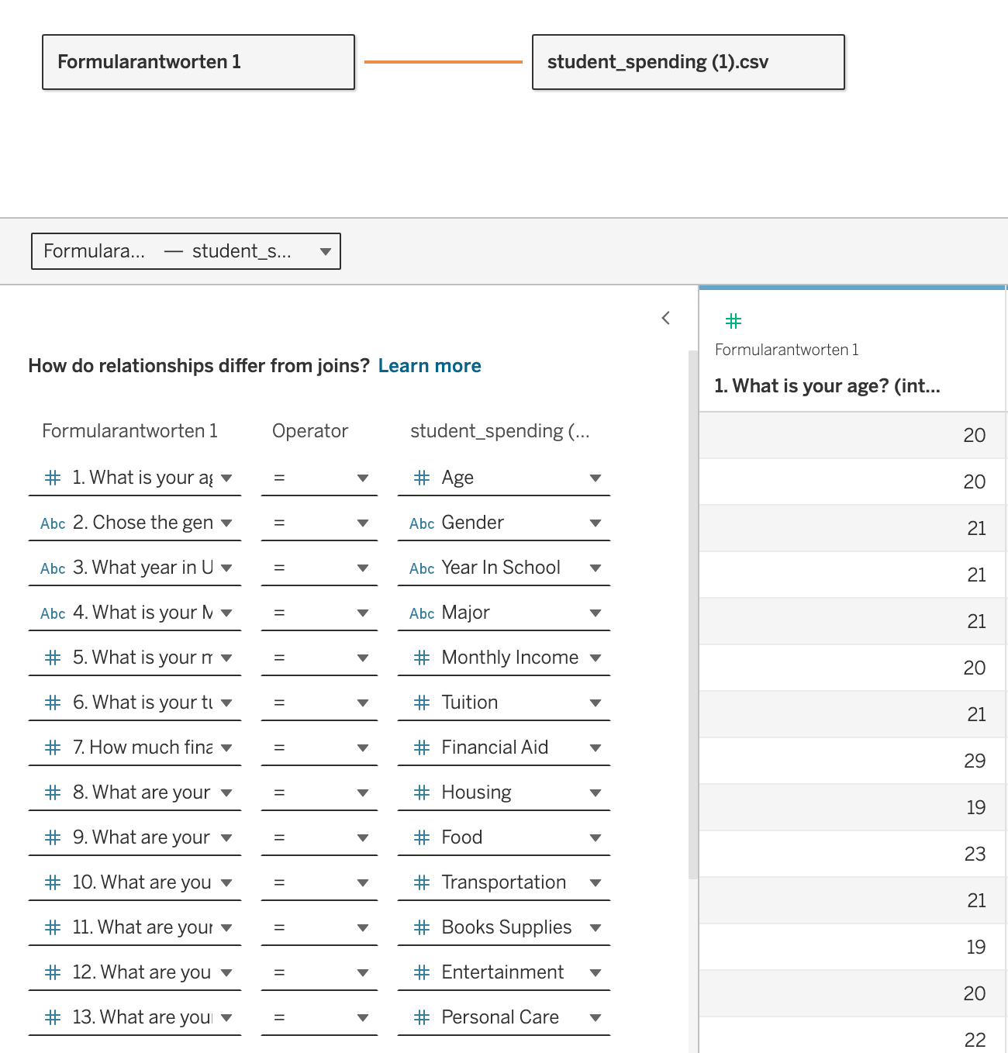
  3. Creating different calculated fields in order to use the data (eg. creating a general spending column & averages)
  4. Creating Graphs to understand the data by visualization

# Analyses & Findings

## 

# Age, Aid, Income & Tuition

**Objective**: To see how much tuition can be covered by aid and income while studying abroad. (Info for prospective students considering to study abroad)

**Data Variables**:

- Y-Axis : Average financial aid + average income - average tuition

- X-Axis: Age (international age)

**Visualization Design**: bar charts for clear representation of financial balances by age

The visualizations provided compare the net financial impact of studying at Inha University versus studying globally for students of various ages.

**Inha University Data Analysis**

- Students at Inha on average enjoy a positive balance even after paying tuition fees out of financial aid or income earned or both combined, except only for a noticeable tip at one point, where the student has neither the financial aid or income to cover his or her own tuition fees. So, the bottom line is that financial aid and income earned here can sufficiently cover or even exceed tuition costs.

**Global Data Analysis**

- The global chart shows consistently negative balances across all age groups from 17 to 25. The average net financial impact ranges from -$2941.9 to -$3132.4 . This suggests that, on a global scale, students generally face a financial shortfall when combining their financial aid and income against tuition costs.

In summary, *Inha University appears to offer a more favorable financial situation to its students, suggesting that those considering to study abroad might find better financial support here compared to other global institutions.* This information is crucial for prospective students as they plan their education and financial strategies.

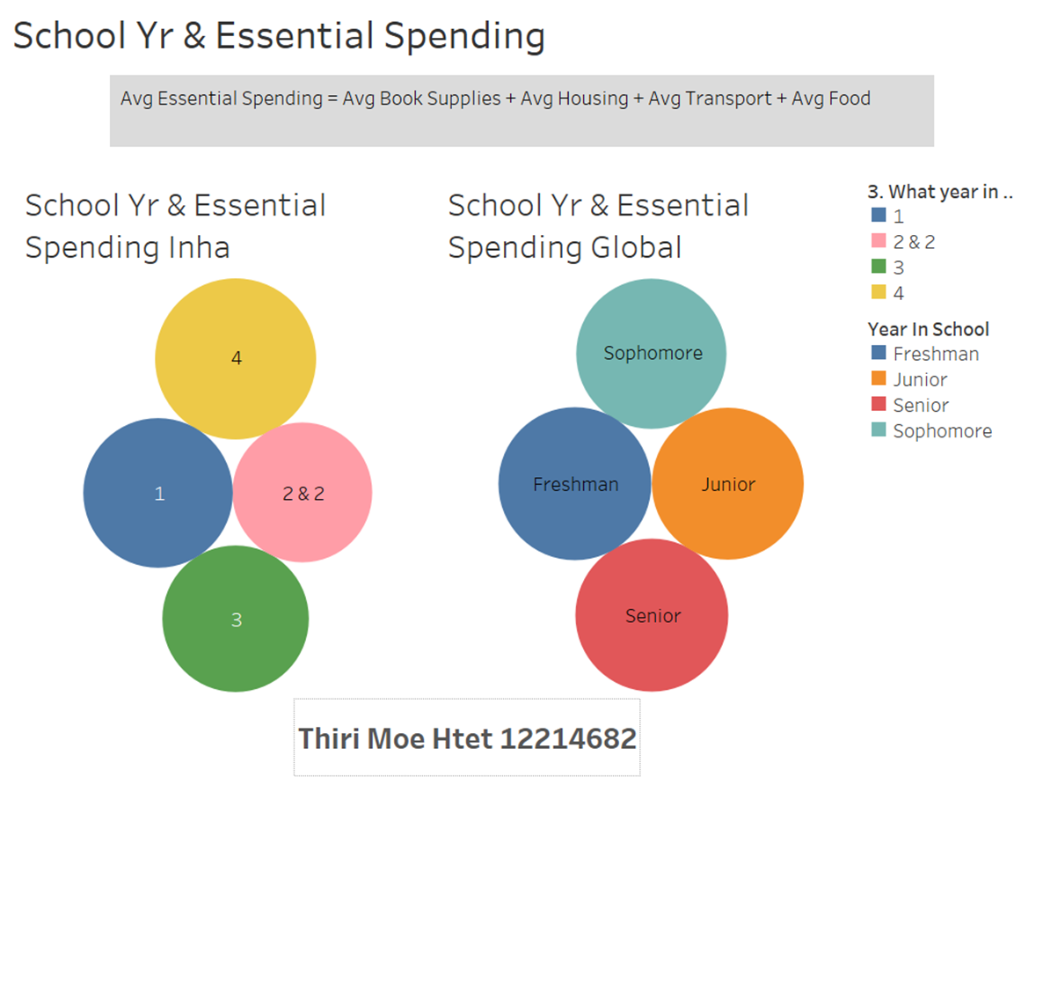

# School Year & Essential Spending

**Objective**:To examine how much essential spending varies across different years at university. (Info for post-admission students who are wondering how to allocate resources)

**Categories**:

- Essential Spending: Includes average book supplies, average housing, average transport, and average food.

-Present School Year

**Visualization Design**: bubble charts to depict essential spending across school years, with size indicating the amount spent.

The visualizations provided compare the average essential spending for students at Inha University and globally across different school years.

**Inha University Data Analysis**

- Freshmen should budget for initial high costs associated with starting university life. Sophomore year might see an increase in essential spending, potentially requiring additional financial planning. Junior year spending stabilizes, providing a relatively predictable financial environment. Senior year brings higher expenses, likely due to transition related costs.

**Global Data Analysis**

- Freshmen globally need to be prepared for substantial initial costs. Sophomore and junior years show relatively stable spending, with a slight increase as students progress. Senior year involves the highest spending, similar to Inha, due to transition-related expenses.

In summary, understanding the variations in essential spending across different school years is crucial for effective financial planning. *Both at Inha University and globally, students experience higher costs in their initial and final years, requiring careful budgeting and resource management.*

Preferred Payment Method & Spending

**Objective:**To examine if students typically safe money when using one specific form of payment and in order to recommend a payment method to students for saving money and to see if Inha students have a different pattern than the global students.

**Categories:**

**-** X-Axis: Average Spending: Food, Books & Supplies, Health & Wellness, Transportation, Entertainment, Personal Care, Technology and Miscellaneous

- X-Axis: Average Spending without necessities: Entertainment, Personal Care, Technology and Miscellaneous

- Y-Axis: Preferred Payment Method

**Visualization Design:** vertical bars to visualize the amount of money spent with each payment method

**Step 1: Creating Calculated Fields of the required Spending**

**Step 2: Creating a Average of those Calculated Fields**

**Step 3: Creating the graphs**

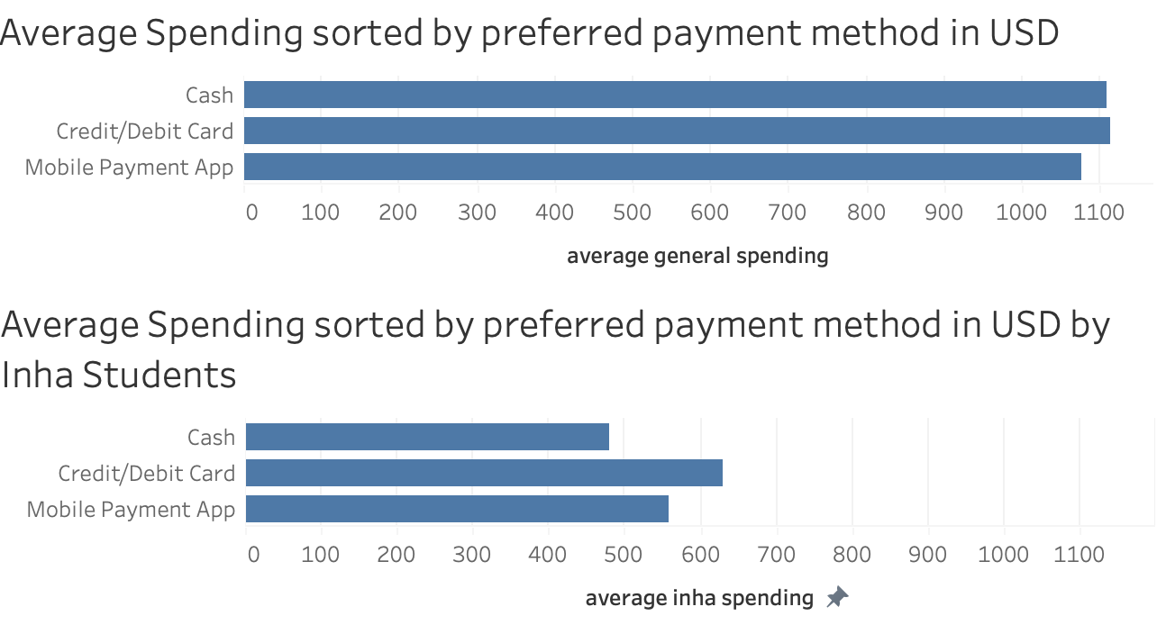

There is not a big difference between paying methods for the general students. Inha students spend slightly less money ($480 vs. $629 & $558) when using Cash.

However the question that arises is that if you only consider “fun” expenses (spending without necessities), does this change?

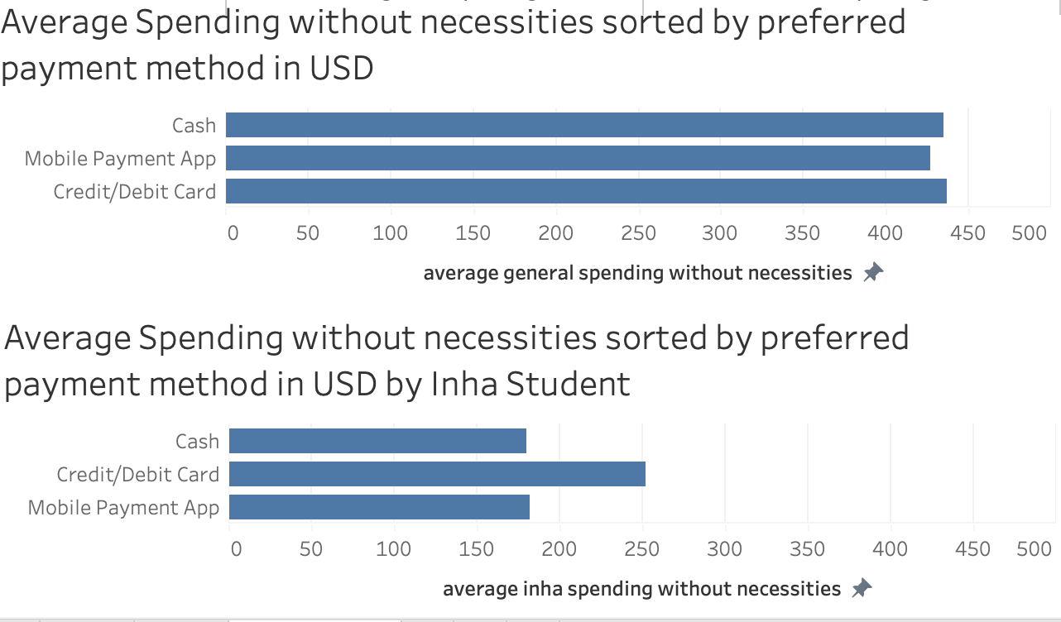

There is still not a big difference between paying methods for the general students. Again Inha students spend slightly less money when using cash, but this time mobile payment apps are also lower. Inha students spent a little more ($252 vs. $180 & $181) when using Credit/Debit Card.

In conclusion, there might be a slight advantage when it comes to paying with Cash as a student from Inha University, however the data is limited and the amount of people that are using Cash as their preferred Payment method was only three. Furthermore the distribution does not really change when you consider only the money that the students have to spend however he likes. Therefore we can conclude that the preferred payment method does not significantly impact the spending.

# 

# Finding the correlation between Housing Expenses and Income

##### Objective:

To compare the housing expenses between Inha University and other universities to assess the affordability of housing for students at our university relative to others.

##### **Step I : Finding Minimun and Maximum Housing Expenses in both dataset**

Firstly to know the minimum and maximum rents students have to spend, a tree map has been created for individual data sources.

##### Model used

Tree maps ( Since the global data set has nearly 1000 rows, it is challenging to view all of them at one glance if a bar graph is used, So, to offer a clear and more visible solution, a tree map has been used.

Findings

1. The lowest house price is $70 whereas the highest is $700 for Inha University students)

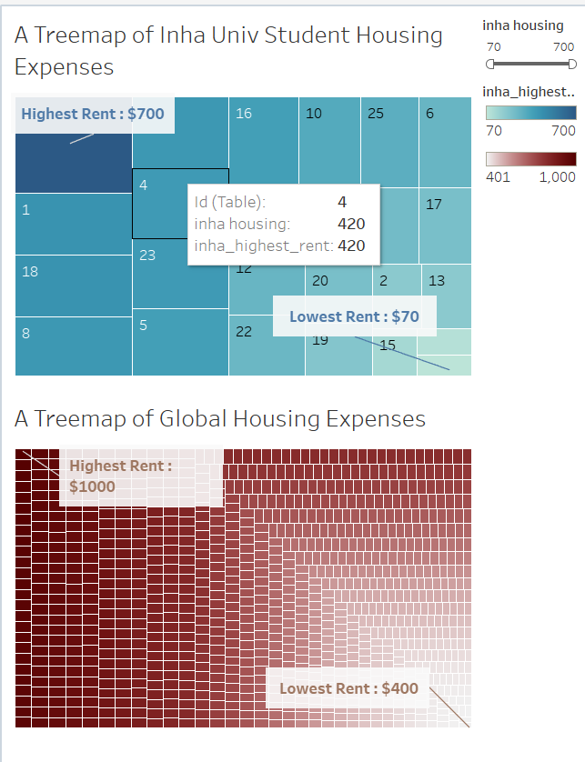

##### **Step 2 : Find the Income-To-Rent Ratio**

###### **Calculation**:

Income-to-Rent Ratio=(Monthly Income + Financial Aid) / Monthly Rent

*Note: All information is based on the monthly rate and in USD.*

###### R**ationale for Using a Ratio Instead of Direct Rent Comparison:**

Given the geographical diversity of the data, a direct comparison of rent prices would be unfair.

For instance, although housing costs are relatively lower in our country compared to South Korea, our average hourly wage is approximately $2.77, whereas it is $7.21 in South Korea. This discrepancy makes housing relatively more affordable in South Korea despite cheaper rental prices.

Results

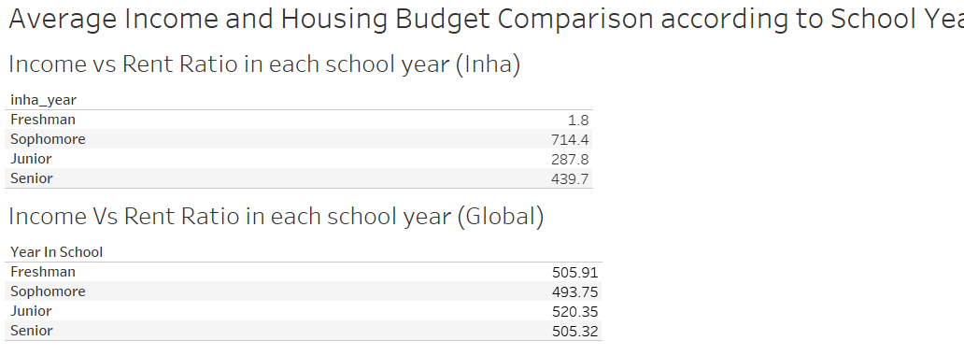

**Others :** The income-to-rent ratio remains relatively constant across all four years, with minor variations of approximately $10.

**Inha University Data:** The income-to-rent ratio for freshmen is notably lower compared to other academic years.

**Potential Explanations:**

International Students: The dataset predominantly consists of international students at Inha University.

These students may face challenges in securing part-time employment upon their initial arrival in Korea.

First-Year Challenges: Freshmen often lack the requisite knowledge and experience to identify affordable housing options.

Housing Vs Financial Aid

Objective: Understanding this correlation can shed light on how well financial aid programs are supporting students in covering their housing expenses. If the financial aid is consistently less than their housing costs, it indicates that students may struggle to afford housing without additional income sources.

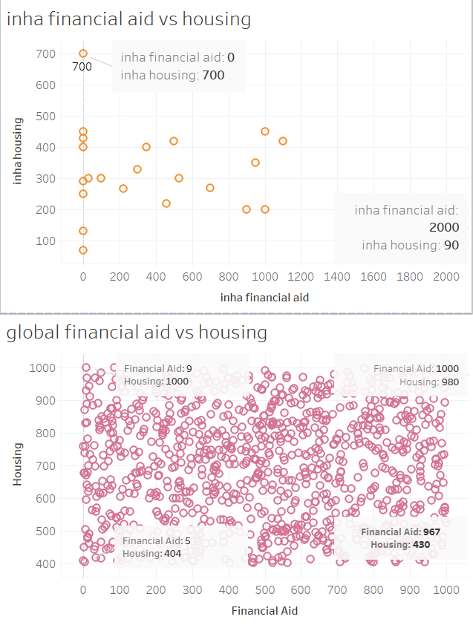

##### Summary of Housing Data

In terms of housing prices, the amount spent by Inha University students is relatively similar to global rental prices with a medium of $300~$500 per month.

According to the Income-rent ratio, Inha students encounter financial hardship in their first year, and the second year (sophomore) students have the best financial situation.

The trend fluctuates throughout 4 years so the best approach for this situation is that students should take enough money from their hometown to cover up the expenses in the first year.

The sophomores might have a lot of disposable money but they should save up ahead for the lower income in the next year.

However, the financial burden would not be as imminent if they had already gone through the first year.

#### Conclusion

In conclusion, the amount of money our student spend on Housing is nearly 60% of total income ( Calculated from average) meanwhile the education expense is barely 0.5%.